

Foundations of Programming

Lab Assignment No. : 03

PROBLEM STATEMENT:
Write a program in C to generate multiplication tables for a given number.
OBJECTIVES:
- To understand the use of looping statements in C.
- To generate multiplication tables using loops.
- To improve program logic and execution flow understanding.

THEORY:
Syntax for for loop example program
Syntax for while loop example program
Syntax for do while loop example program

ALGORITHM:
- Start
- Declare variables num and i
- Ask the user to enter a number
- Read the number num
- Set i = 1
- Repeat the following steps while i ≤ 10
  - Calculate num × i
  - Display the result
  - Increase i by 1
- Stop
FLOWCHART :
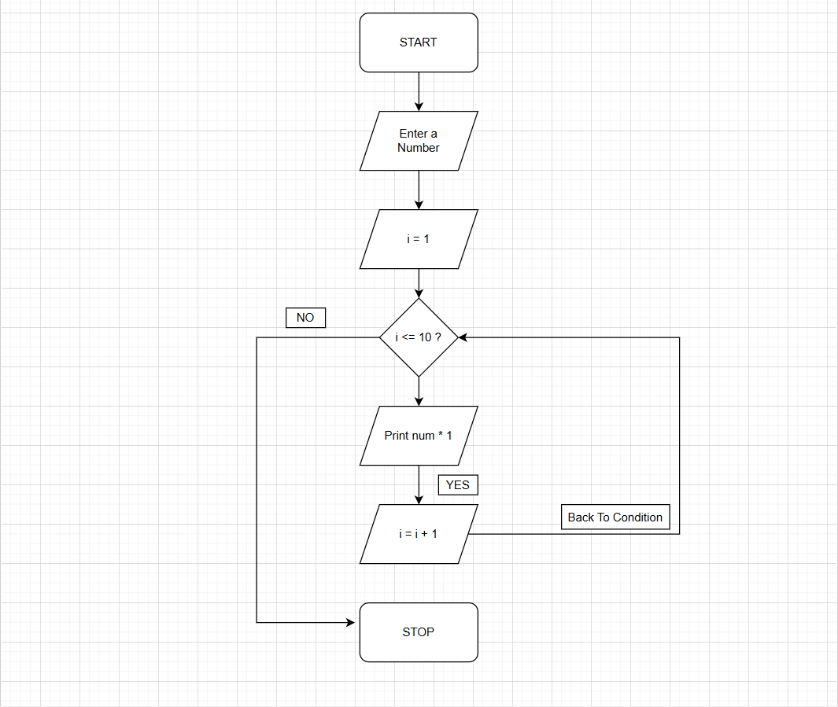

PLATFORM:
Linux

CODE :
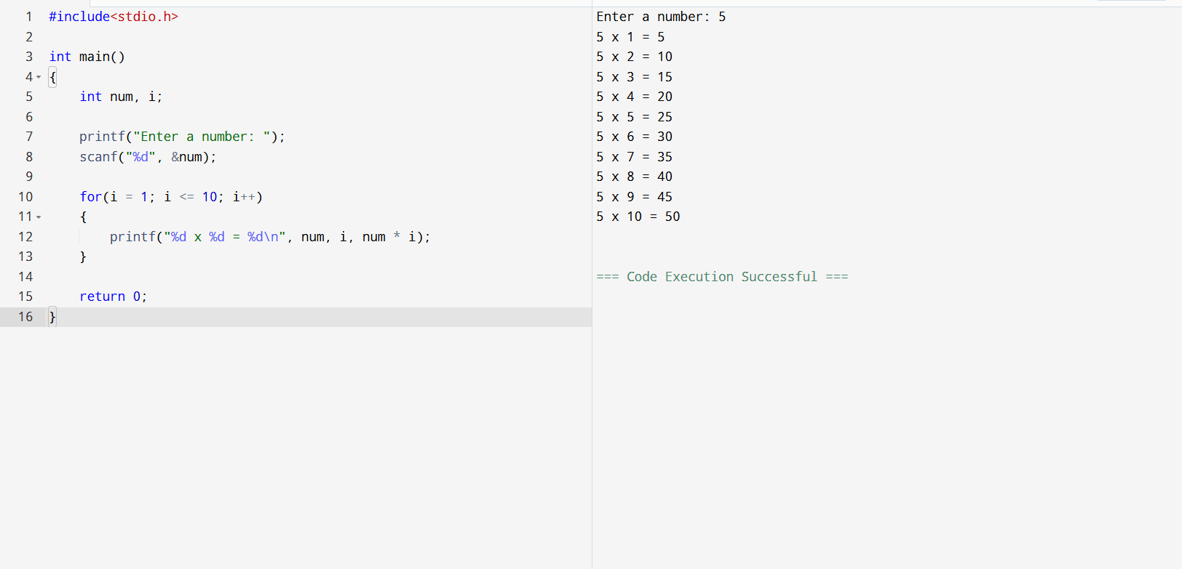
INPUT:
Choice of operation and two numbers

OUTPUT:
Displays the result of the selected arithmetic operation
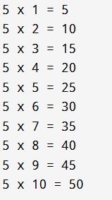

CONCLUSION:
Thus, the menu driven program in C successfully performs basic arithmetic operations using switch–case statements.

FAQs:
- Which loop is best suited for generating multiplication tables?
- What is the role of loop initialization?
- Difference between for loop, while loop and do while loop?
- Can a do–while loop be used to generate multiplication tables? Explain.
- Why is the do–while loop called an exit-controlled loop?

